Retail Sales Intelligence Dashboard
1. Project Overview:
The Retail Sales Intelligence Dashboard is an end-to-end retail analytics project developed using MySQL and Power BI. The objective of this project was to transform raw retail transaction data into actionable business insights through extensive SQL-based analysis and interactive dashboard visualization.
The project follows a SQL-first approach where data exploration, business analysis, customer segmentation, product segmentation, KPI generation, and reporting layers were implemented in MySQL before being visualized in Power BI.
2. Business Problem Statement:
The retail business generates thousands of sales transactions across multiple products and customers. However, raw transactional data alone does not provide meaningful insights for decision-making.
The business needs answers to critical questions such as:
- Which products generate the highest revenue?
- Which products are underperforming?
- Who are the most valuable customers?
- How does sales performance change over time?
- Which product categories contribute the most to overall revenue?
- How can customers be segmented based on purchasing behavior?
- Which customers are at risk of becoming inactive?
- What opportunities exist to improve revenue and customer retention?
And many more questions.
To address these challenges, a SQL & Power BI deriven analytics solution was developed to transform raw sales data into actionable insights through exploratory analysis, advanced analytics, customer segmentation, product performance evaluation, and interactive business reporting.
3. Technologies Used:
Database: MySQL
Visualization: Power BI
SQL Concepts Applied:
- Joins
- Aggregate Functions
- CASE Statements
- Date Functions
- Subqueries
- Common Table Expressions (CTEs)
- Window Functions
- ROW_NUMBER()
- LAG()
- Running Totals
- Moving Averages
- Ranking Analysis
- Customer Segmentation
- Product Segmentation
- Views
4. Dataset Summary:
The dataset follows a Star Schema design consisting of one fact table and two dimension tables.
Table | Rows | Description
fact_sales | 60,398 | Sales transactions
dim_customers | 18,484 | Customer information
dim_products | 294 | Product information
5. Sales Coverage:
- Analysis Period: December 2010 – January 2014
- Total Customers: 18,484
- Total Products Available: 294
- Products with Sales Activity: 130
6. Key Tables:
dim_customers: customer_key, customer_id, customer_number, first_name, last_name,
country, gender, marital_status, birthdate, create_date
dim_products: product_key, product_id, product_number, product_name, category, subcategory, category_id, cost, maintenance, product_line, start_date
fact_sales: order_number, customer_key, product_key, order_date, shipping_date, due_date, sales_amount, quantity, price
7. Exploratory Data Analysis (EDA):
The first phase focused on understanding the dataset structure, validating data quality, and generating baseline business metrics.
Activities Performed:
- Database creation and schema setup
- Data loading using CSV imports
- Record count validation
- Missing value handling
- Dimension exploration
- Date range analysis
- Measure exploration
Core Business Metrics Generated:
- Total Sales
- Total Orders
- Total Quantity Sold
- Total Customers
- Total Products
- Average Selling Price
Data Quality Handling:
Missing birthdate values imported as 0000-00-00 were identified and converted to NULL values to ensure accurate age calculations and customer analysis.
8. Advanced Data Analysis Using SQL
A comprehensive business analysis layer was built using advanced SQL techniques.
Magnitude Analysis:
Analyzed business performance across:
- Countries
- Gender
- Product Categories
- Customer Revenue
- Product Revenue
Ranking Analysis:
Identified:
- Top 5 Revenue Generating Products
- Bottom 5 Performing Products
- Top 10 Customers by Revenue
- Customers with Lowest Order Activity
Change Over Time Analysis:
Performed time-series analysis on:
- Yearly Sales Trends
- Monthly Sales Trends
- Customer Growth Trends
- Quantity Sold Trends
Cumulative Analysis:
Implemented Window Functions to calculate:
- Running Total Sales
- Moving Average Price
- Cumulative Revenue Trends
Performance Analysis:
Used CTEs and LAG() functions to compare:
- Current Year Sales
- Previous Year Sales
- Product Growth Performance
- Average Product Performance
Part-to-Whole Analysis:
Calculated category contribution to overall revenue and identified major revenue drivers.
Data Segmentation:
1.Customer Segmentation:
Customers were classified into:
- VIP
- Regular
- New
based on spending behavior and purchase lifespan.
2.Product Segmentation:
Products were classified into:
- High Performer
- Mid-Range
- Low Performer
based on generated revenue.
9. Customer and Product Reporting Views:
To support scalable reporting and dashboard development, two analytical views were created using CTEs and aggregation logic.
Customer Report View:
The customer reporting layer contains:
- Customer Information
- Age & Age Group
- Customer Segment
- Total Orders
- Total Sales
- Total Quantity Purchased
- Total Products Purchased
- Lifespan
- Recency
- Average Order Value
- Average Monthly Spend
Product Report View:
The product reporting layer contains:
- Product Information
- Category & Subcategory
- Product Segment
- Total Orders
- Total Sales
- Total Quantity Sold
- Total Customers
- Product Lifespan
- Product Recency
- Average Selling Price
- Average Order Revenue
- Average Monthly Revenue
These views served as the final reporting layer consumed directly by Power BI.
10. Dashboard Creation:
Power BI was connected directly to the SQL reporting views to create interactive dashboards.
Product Analysis Dashboard:
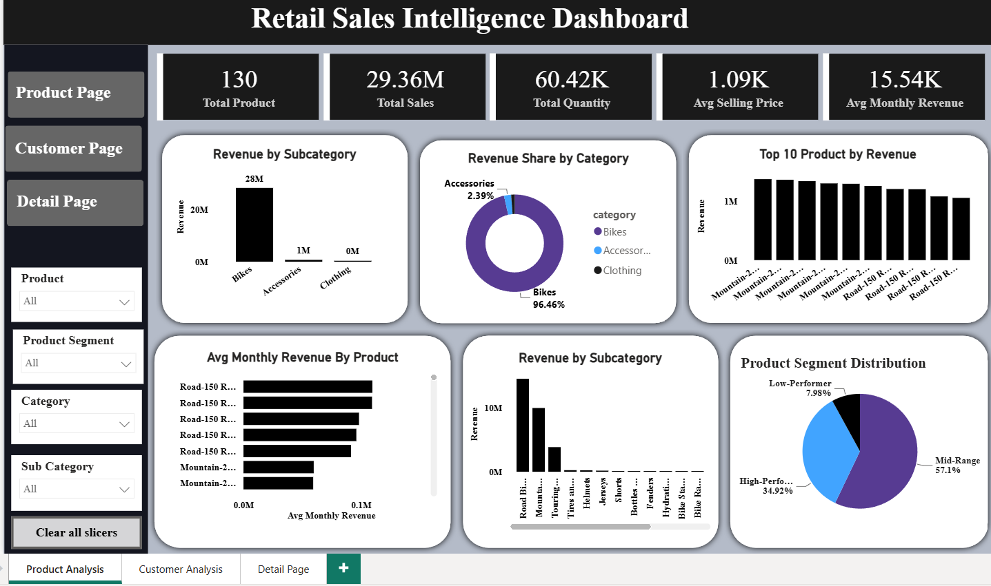

Customer Analysis Dashboard:
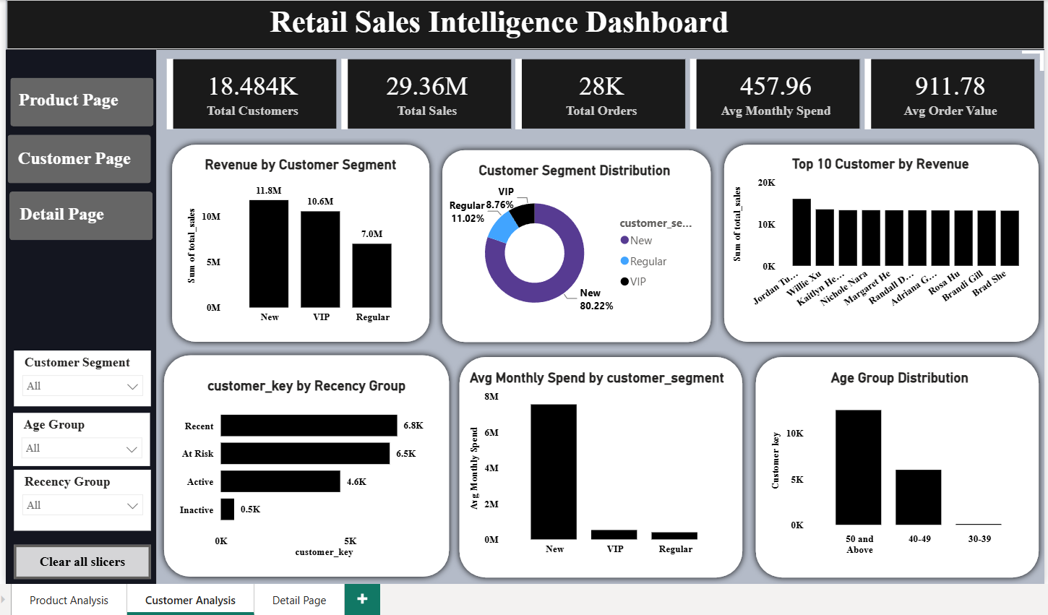
Detail Dashboard:
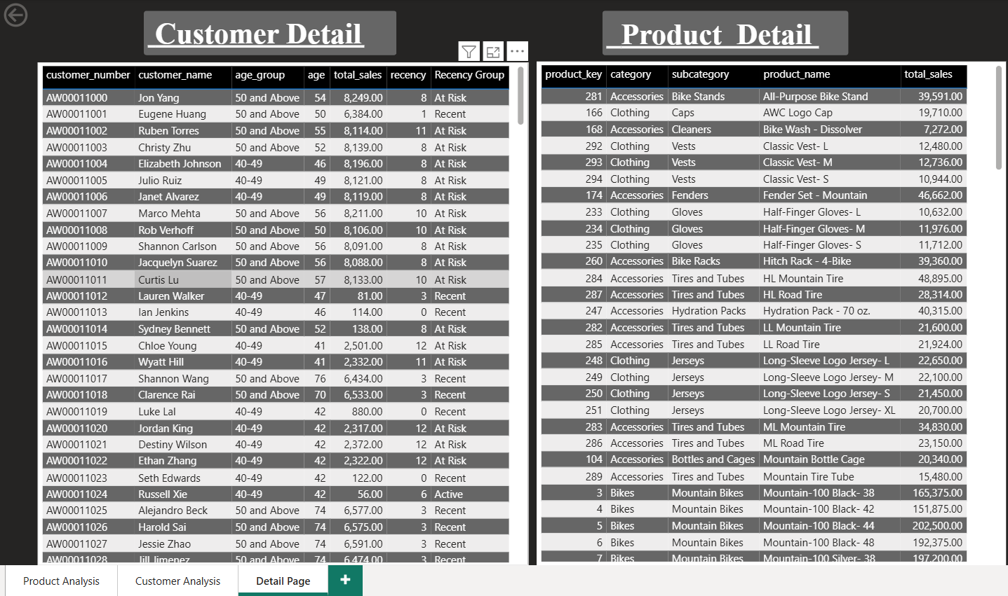
11. Dashboard Metrics:
Product Dashboard Highlights:
Metric | Value
Products With Sales | 130
Total Sales | 29.36M
Total Quantity Sold | 60.42K
Average Selling Price | 1.09K
Average Monthly Revenue | 15.54K
Customer Dashboard Highlights:
Metric | Value
Total Customers | 18.48K
Total Sales | 29.36M
Total Orders | 28K
Average Monthly Spend | 457.96
Average Order Value | 911.78

12. Real Insights From Dashboard:
1.Customer Segment Analysis:
Segment | Share
New Customers | 80.22%
Regular Customers | 11.02%
VIP Customers | 8.76%
Insight:
- Majority of customers are classified as New Customers.
- VIP customers form less than 10% of the customer base but contribute significantly to revenue.
- Opportunity exists to convert New customers into long-term customers.
2.Product Segment Analysis:
Segment | Share
Mid-Range | 57.1%
High Performer | 34.92%
Low Performer | 7.98%
Insight:
- More than half of products belong to the Mid-Range category.
- Only a small percentage of products are low performers.
- High-performing products drive a substantial portion of business revenue.
3.Revenue Contribution by Category:
Category | Revenue Share
Bikes | 96.46%
Accessories | 2.39%
Clothing | ~1%
Insight
- Revenue is heavily concentrated in the Bikes category.
- Accessories and Clothing have potential for cross-selling opportunities.
4.Product Utilization Analysis:
Metric | Value
Total Products Available | 294
Products Generating Sales | 130
Utilization Rate | 44.2%
Insight
- Only 44% of products generated sales.
- More than half of the product catalog showed little or no sales activity.
- Product portfolio optimization can improve inventory efficiency.
13. Key Insights
Product Insights:
- Out of 294 available products, only 130 generated sales.
- Product utilization rate was approximately 44%.
- Bikes generated 96.46% of total revenue.
- Accessories contributed 2.39% of total revenue.
- Clothing contributed less than 1.5% of total revenue.
- Mid-Range products represented the largest product segment (57.1%).
Customer Insights:
- New Customers represented 80.22% of the customer base.
- Regular Customers represented 11.02%.
- VIP Customers represented 8.76%.
- VIP customers generated a significant share of revenue despite their smaller population.
- Recency analysis identified active, at-risk, and inactive customer groups.
Business Insights:
- Revenue is heavily concentrated within the Bikes category.
- Product sales are concentrated among a relatively small set of products.
- Significant opportunities exist for customer retention and product portfolio optimization.
14. Business Recommendations:
Product Strategy:
- Focus inventory planning on high-performing products.
- Review low-performing products for optimization or discontinuation.
- Increase promotion of profitable product categories.
Customer Strategy:
- Develop loyalty programs for VIP customers.
- Launch retention campaigns targeting inactive customers.
- Create incentives to convert New customers into Regular and VIP customers.
Revenue Growth Strategy:
- Expand high-performing product categories.
- Implement cross-selling opportunities for accessories and clothing.
- Continuously monitor customer and product performance using analytical reporting.
15. SQL Skills Demonstrated:
This project demonstrates practical application of:
- Data Modeling
- Data Cleaning
- Data Validation
- Joins
- Aggregations
- CASE Statements
- Date Functions
- Subqueries
- Common Table Expressions (CTEs)
- Window Functions
- ROW_NUMBER()
- LAG()
- Running Totals
- Moving Averages
- Ranking Analysis
- Segmentation Analysis
- Reporting Views
- Business Intelligence Reporting
16. Conclusion:
This project showcases how SQL can be used as the primary analytical engine for transforming raw transactional data into meaningful business insights. Through extensive use of aggregations, CTEs, window functions, ranking analysis, segmentation, and reporting views, a complete analytical framework was developed to evaluate customer behavior, product performance, and revenue trends.
Power BI was then used as the visualization layer, enabling interactive exploration of insights generated through SQL-driven analytics.

